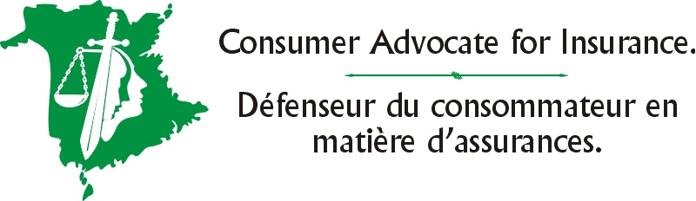

Consent Form

To : __________________________

__________________________

__________________________

__________________________

Date: __________________________

Re: __________________________

__________________________

__________________________

__________________________

You are hereby authorized to divulge, communicate and provide to the office of the Consumer Advocate for Insurance of New Brunswick any and all information, records or documents as requested by the said office of the Consumer Advocate in relation to me, the undersigned.

You are hereby released from the provisions of the Privacy Act for the purpose of complying with this request.

X .

